

**IAR EW for 8051 software registration**

**Table of contents**

1. Introduction and Installation

2. Registration statement

3. Software Download and Registration

4. Frequently asked questions

**1. Introduction and Installation**

Please refer [to:](https://link.zhihu.com/?target=https%3A//www.kancloud.cn/aiot/zigbee/2486379)https://www.kancloud.cn/aiot/zigbee/2486379

**2. Registration statement**

IAR EW [for 8051](https://zhida.zhihu.com/search?content_id=207037497&content_type=Article&match_order=1&q=for+8051&zhida_source=entity) is a paid development software. **If you use it for commercial purposes, please be sure to support genuine software** ! If you use it for personal learning, you can use the official 30-day free trial version.

This article is intended to provide non-commercial learning assistance for individual learning users. All the following information comes from the Internet. If it damages your interests or infringes on your rights, please contact the author to delete it.

The content of this section is for reference only. The author does not provide technical support for the content of this section **in principle**. Please operate it yourself if necessary.

**3. Software Download and Registration**

After downloading the course resources, unzip IAR EW for 8051 10.10.1.zip to get a registration software named "IAR_UniversalKEY", as shown in the figure.

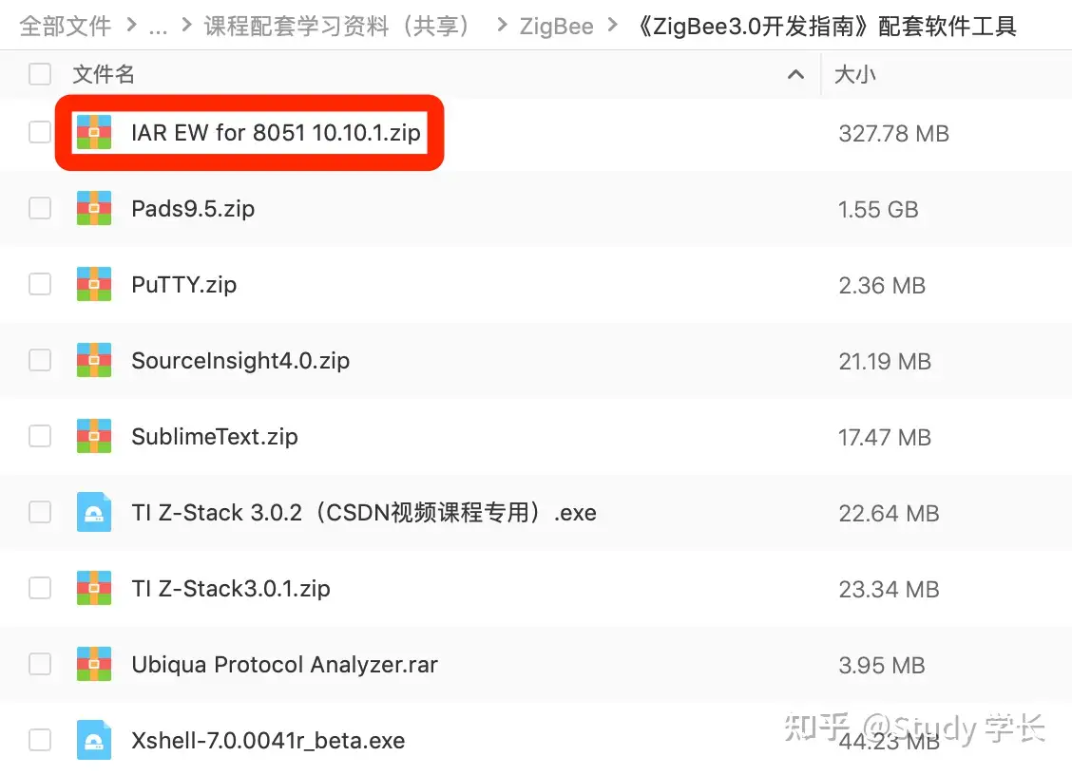

Run the activation software and generate the registration code according to the steps in the picture. **Note: Do not close the software during this period!**

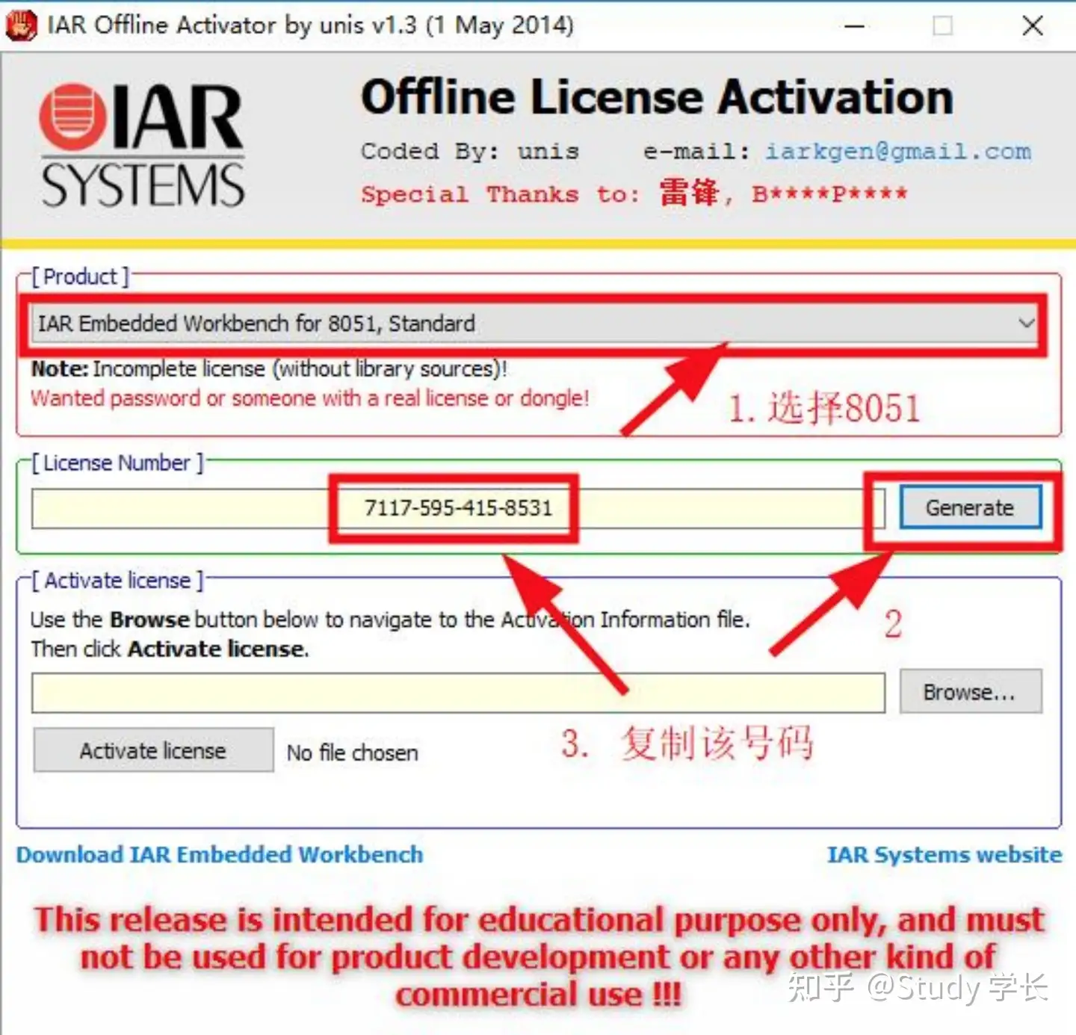

Copy the registration code into the dialog box that pops up during the installation step, as shown in the figure.

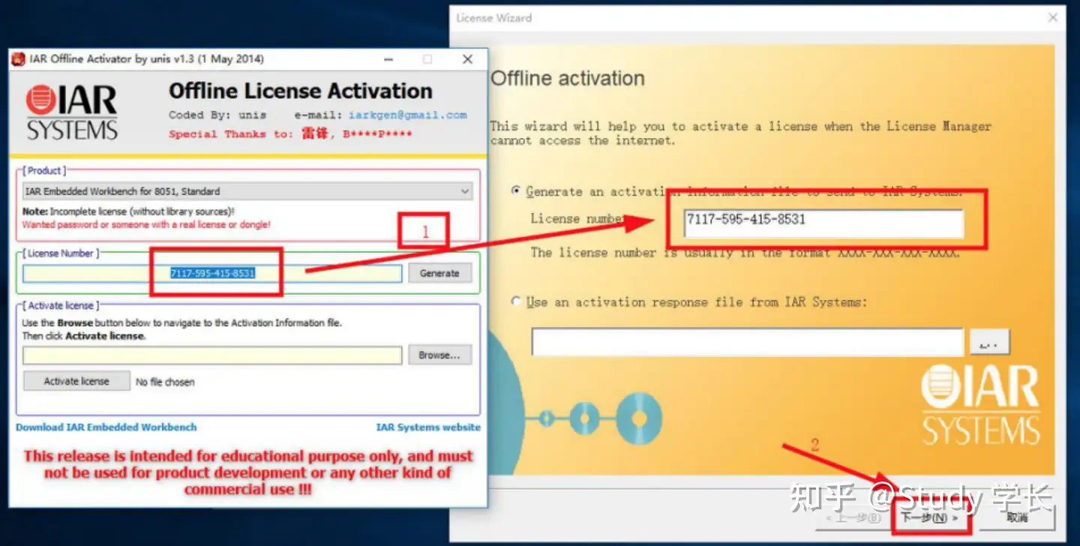

Select No to not associate a Dongle.

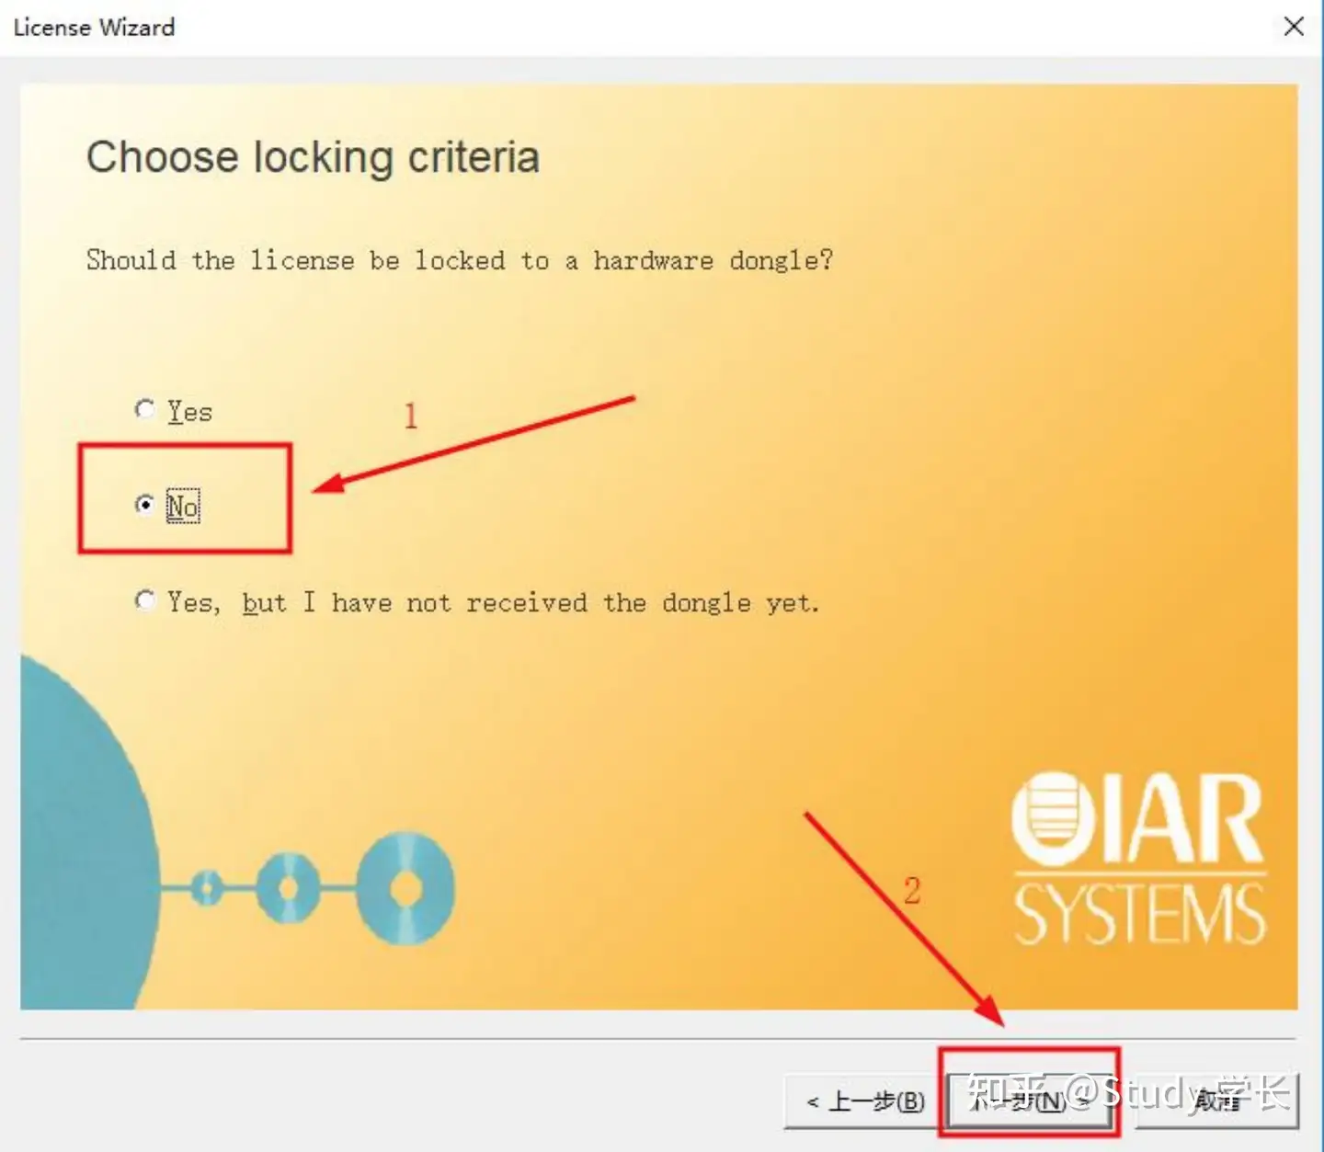

Select the installation directory of IAR EW for 8051 to save the files to be generated

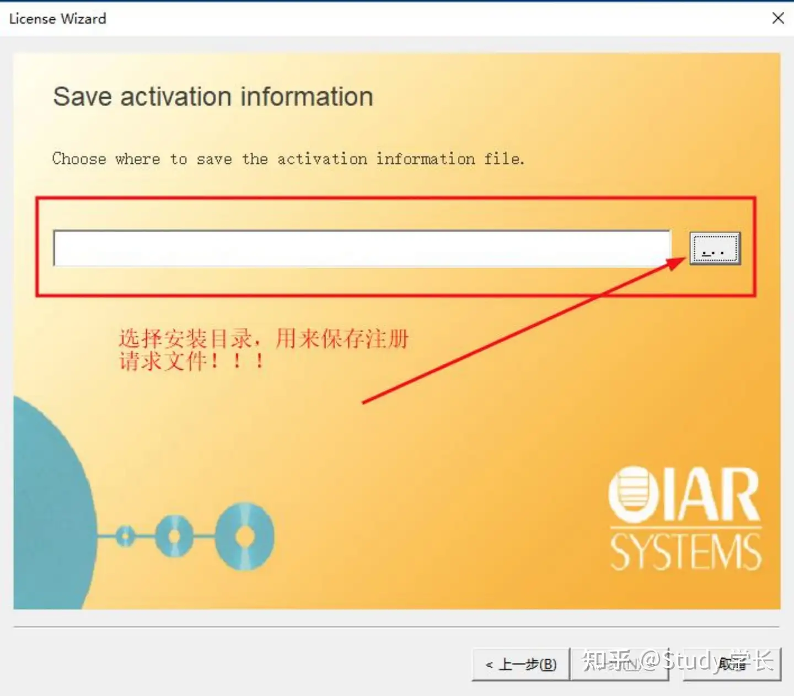

After selecting the directory, click Save and an ActivationInfo.txt file will be generated.

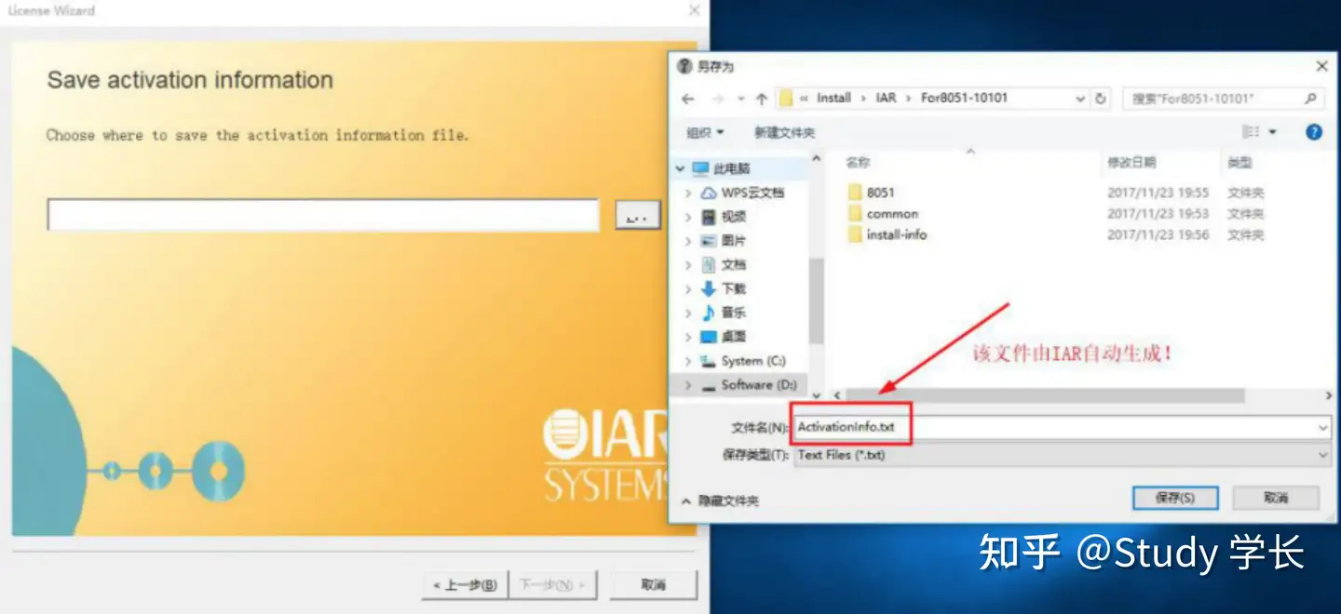

Click Next.

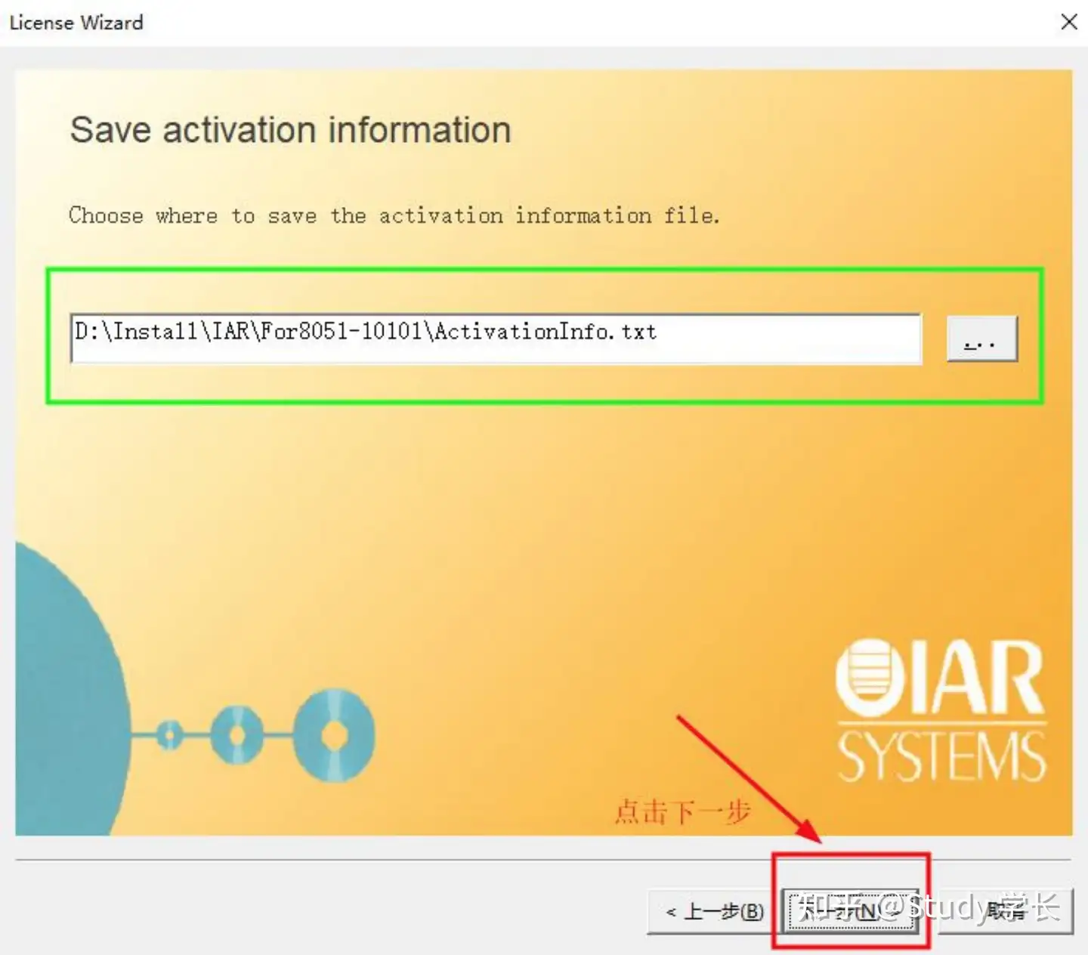

Click Next.

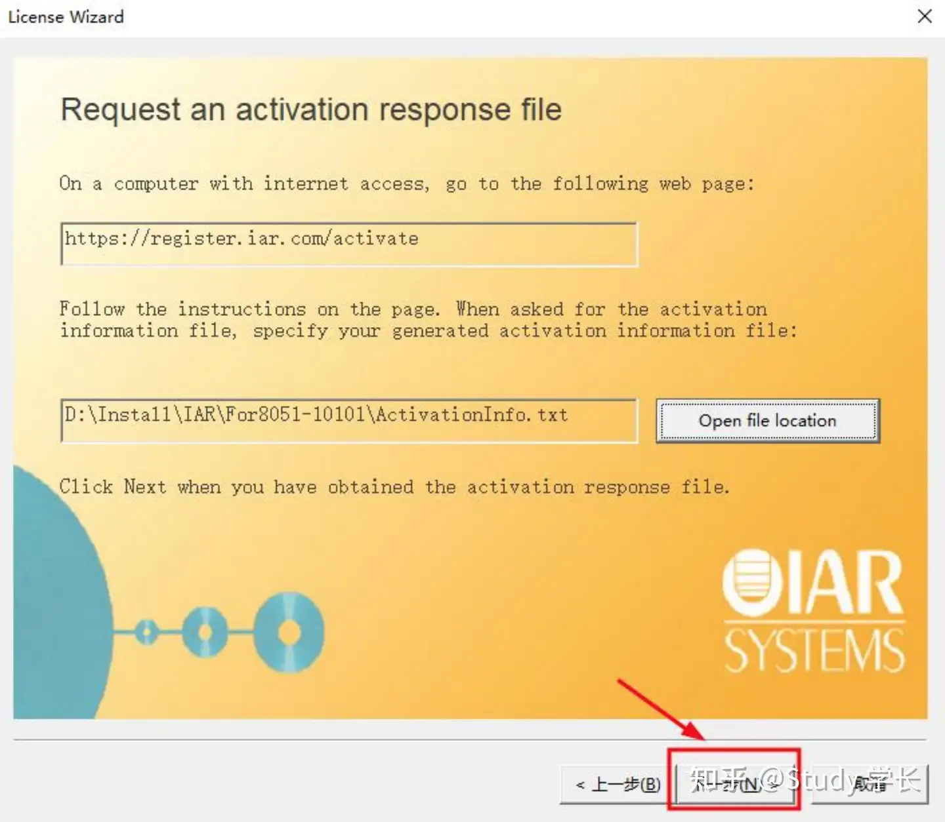

The dialog box indicates that you need to input the registration file (generated by [the registration software](https://zhida.zhihu.com/search?content_id=207037497&content_type=Article&match_order=2&q=%E6%B3%A8%E5%86%8C%E8%BD%AF%E4%BB%B6&zhida_source=entity) ) and return to the registration software.

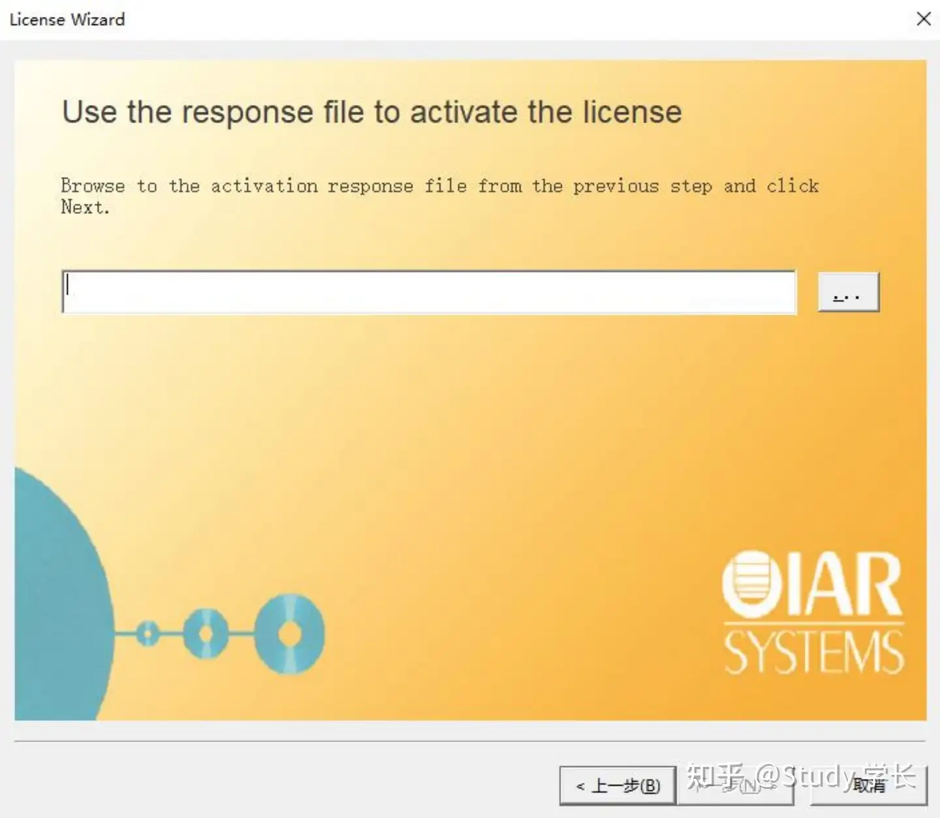

Select the ActivationInfo.txt file generated in step 4 as shown in the figure.

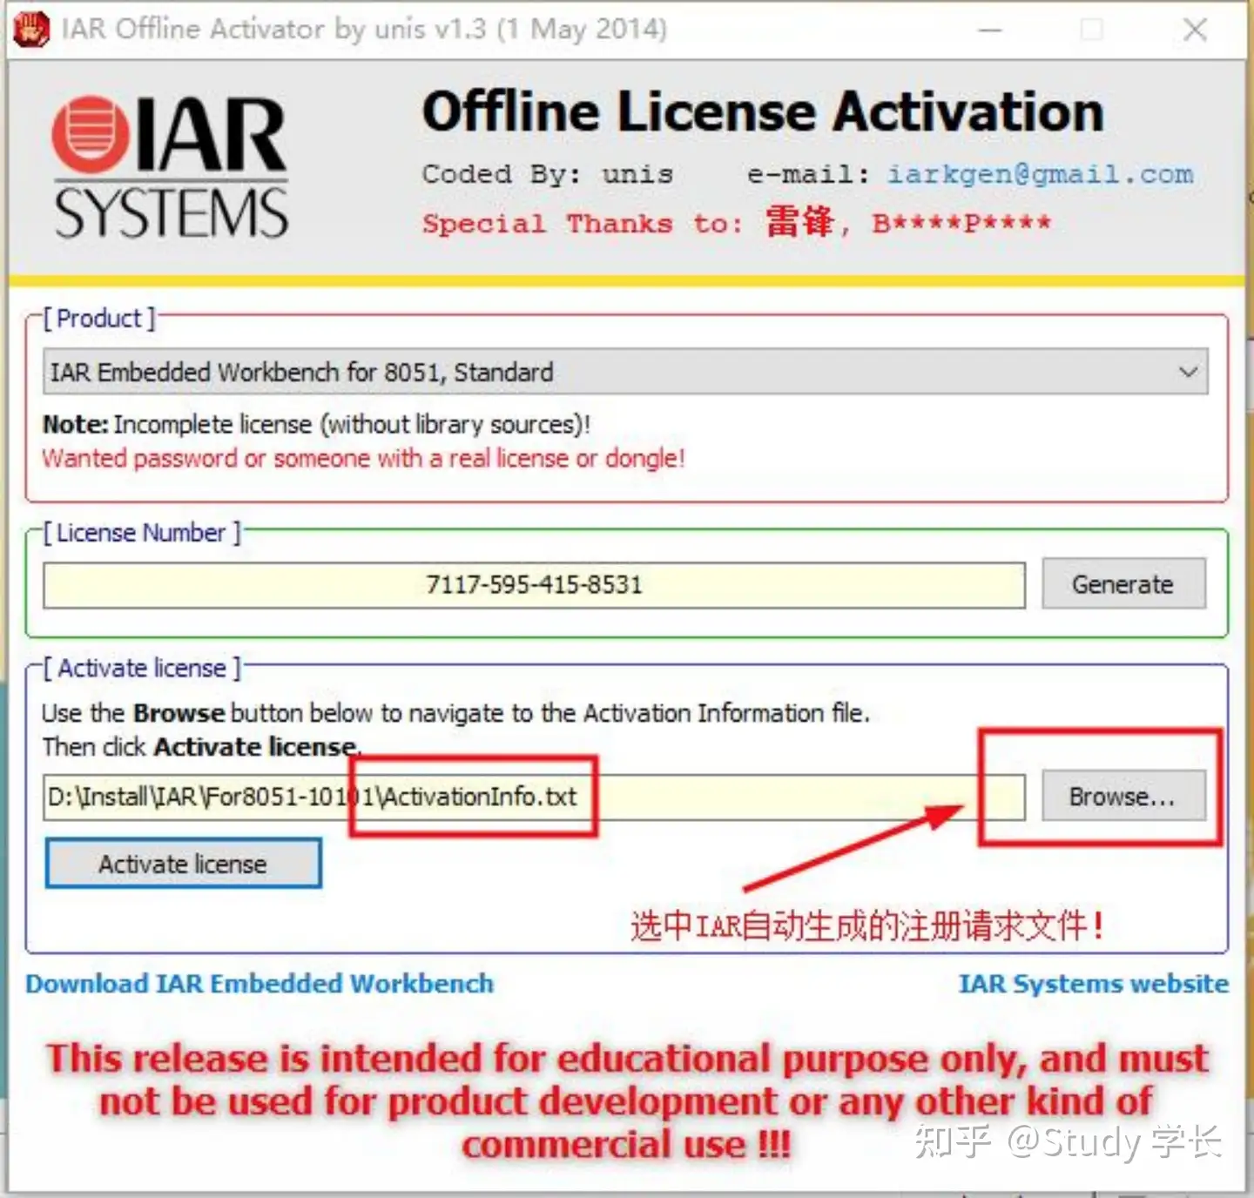

Click "Activate license" and select the installation directory to save the generated registration file.

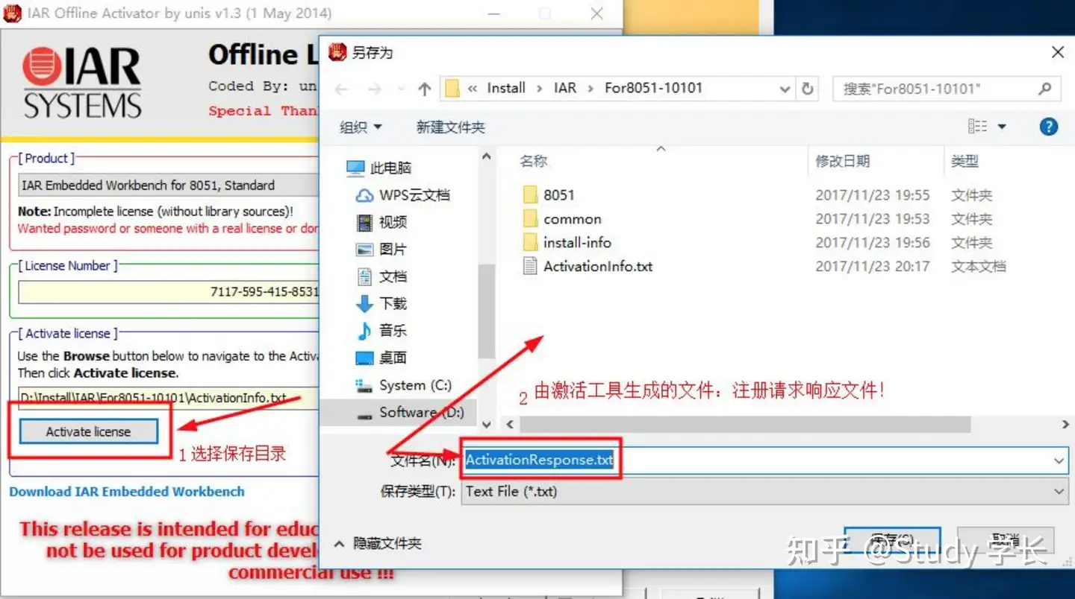

After saving the registration file: ActivationResponse.txt, the following dialog box pops up to indicate successful registration.

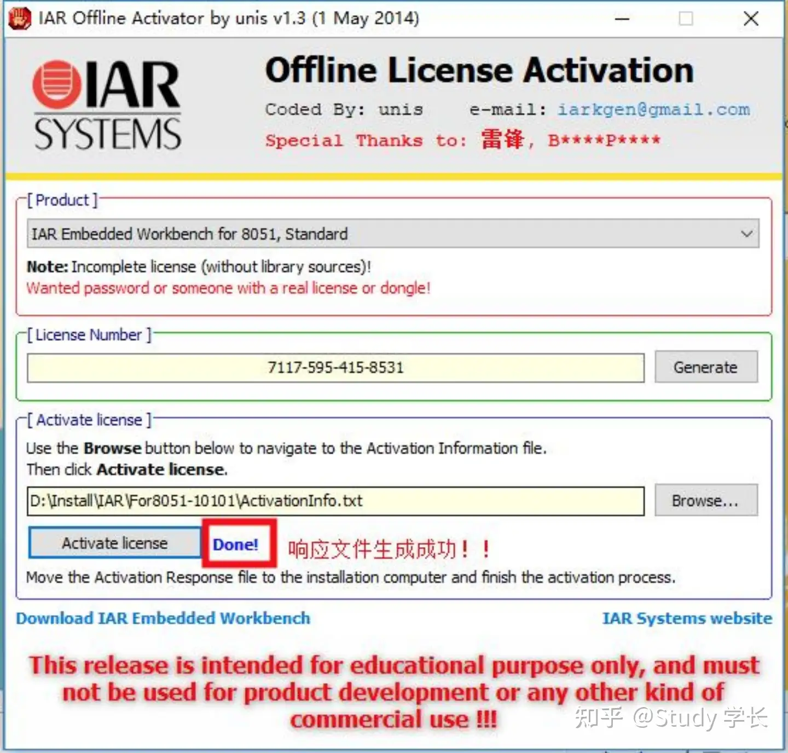

Import the registration file into the dialog box that pops up in step 7.

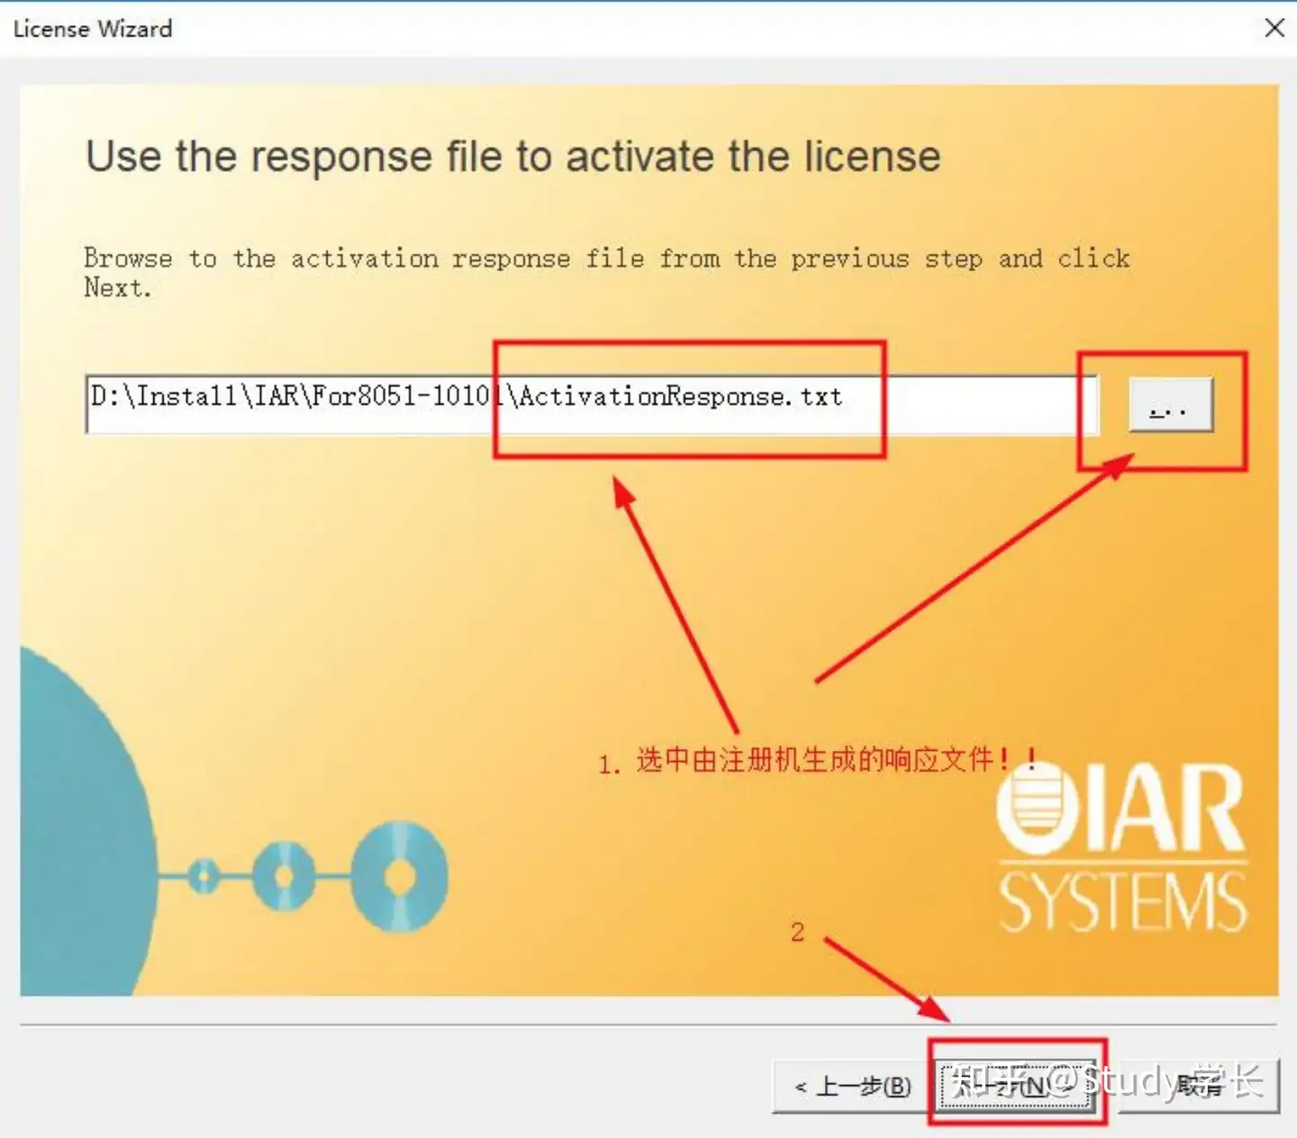

The following dialog box pops up to indicate that activation is complete.

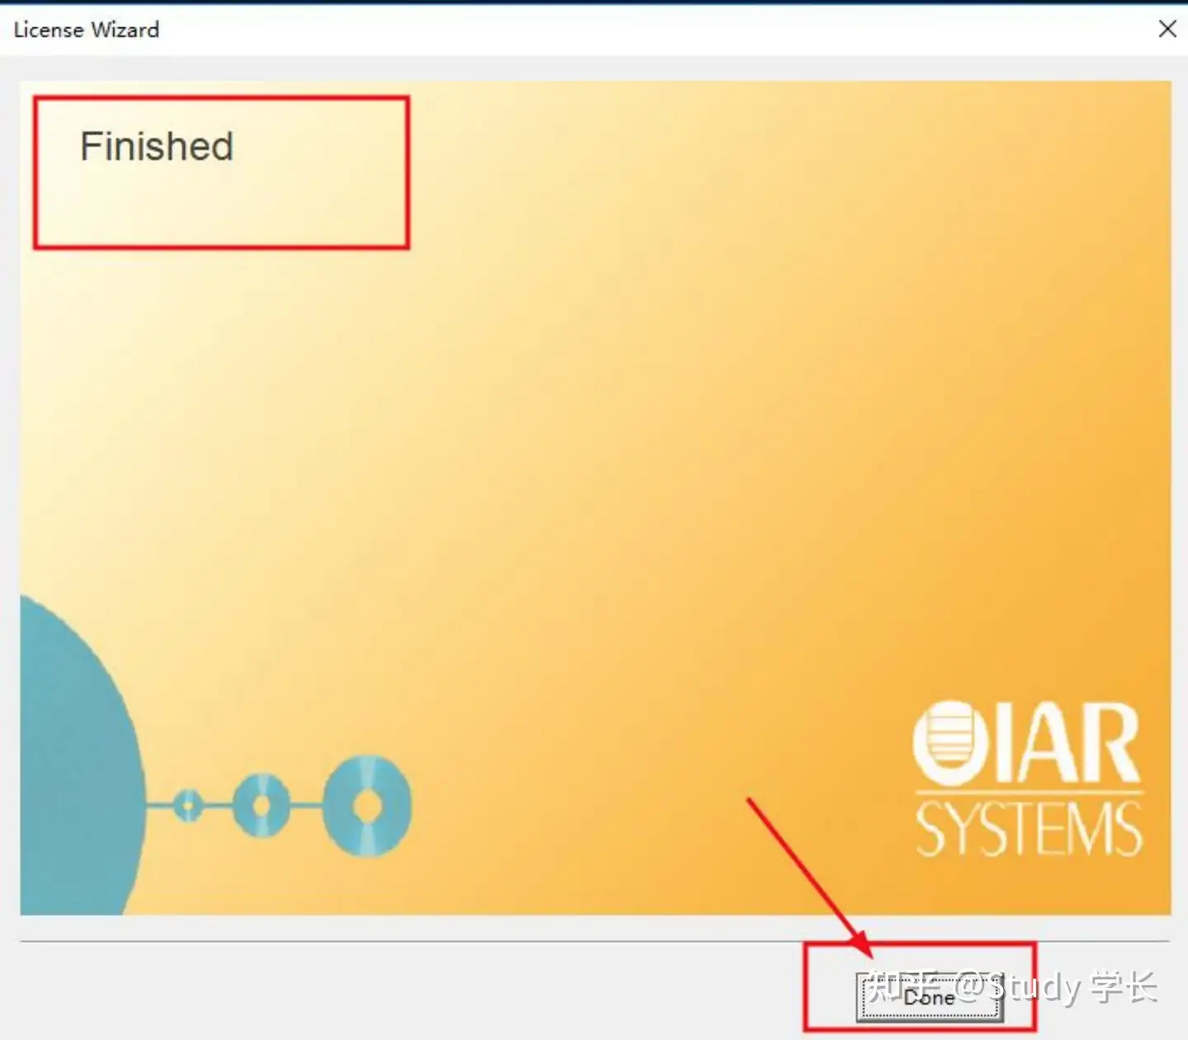

Select No to not export the file.

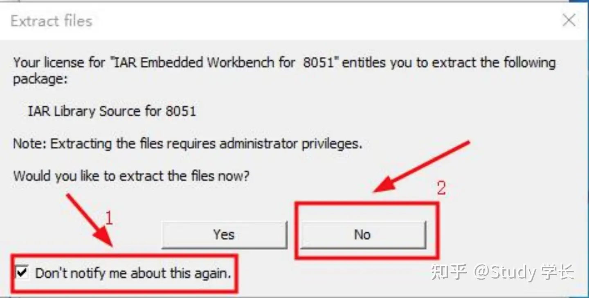

Check whether the registration is complete, then click the Exit button

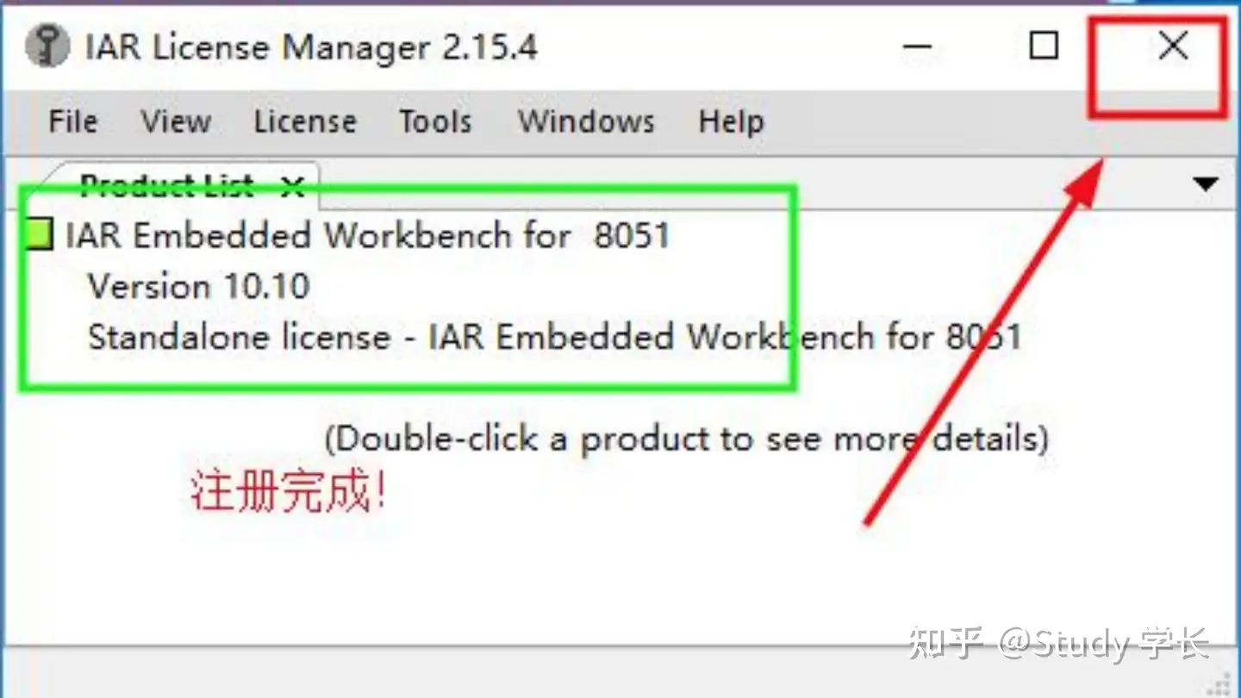

Click Exit to exit the IAR installer.

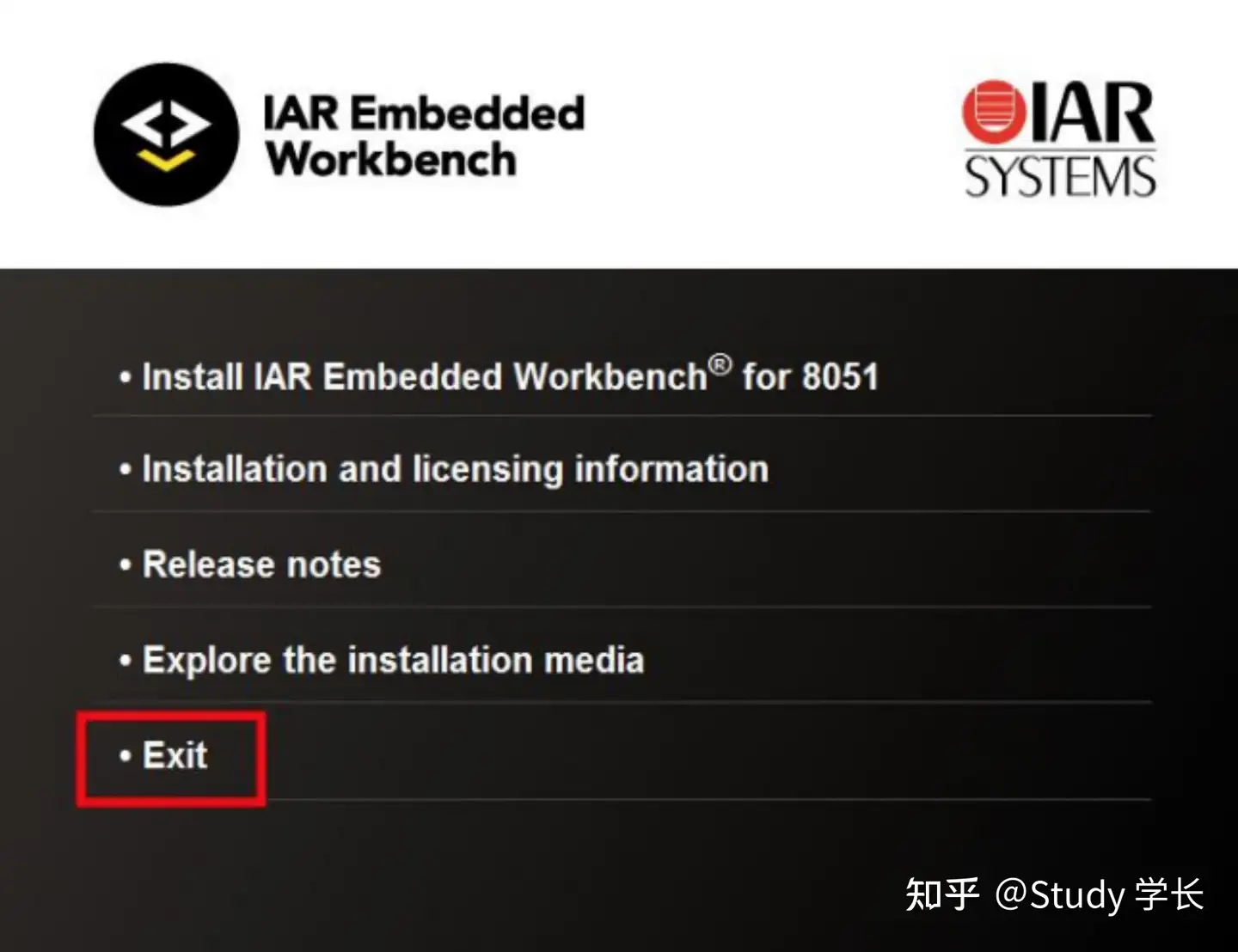

After closing the registration tool, close IAR and then restart it.

**4. Frequently asked questions**

When registering software, what should I do if the message "Could not get imformation for the given license number" appears after entering the license number?

Carefully check every step of the tutorial and follow it exactly.

Unplug the network cable from the computer, turn off the WiFi completely, and turn off any other networks, then try again;

If you have installed other versions of IAR, you can try to crack the code with other versions;

Try again on another computer;

The registered software may not be applicable to the new IAR version. You can use the IAR version provided by the author.

If the above methods still cannot solve other problems, you can try other methods.